KENDALL TOWN BOARD
Tuesday, January 17, 2017 7:00 p.m.
Kendall Town Hall – 1873 Kendall Road, Kendall, New York 14476

Supervisor Cammarata called the meeting to order at 7:04 p.m., and led the Pledge of Allegiance.

ROLL CALL
Councilwoman Flow present
Councilman Martin excused
Councilman Newell excused
Councilwoman Szozda present
Supervisor Cammarata present

SUPERVISOR’S REMARKS
Invoice for Town of Carlton’s portion of the Assessor’s salary has been sent.
Water District Seven – meeting was held with USDA representative and LaBella representative, to review the next step the Town Board has to take, since the grant was awarded. Another meeting is necessary to clarify. Construction is scheduled to start in the Spring.

CORRESPONDENCE
Justice Court Assistance Program – grant awarded to Kendall Justice Court
Volkmar letter regarding active military personnel recognition
DOT – letter of intent to investigate reduction of speed limit on Rte. 18

PUBLIC COMMENT
Donald Mann, Kendall Road, expressed appreciation for the Town library being available in the Town Hall, particularly the books on tape.

REPORTS OF COMMITTEES, BOARDS AND DEPARTMENT HEADS
Standing Committees

Public Safety/Emergency Services & Occupational Safety – Martin
Buildings & Grounds – Martin
Highway – Martin
No report

Community Relations - Flow
Culture & Recreation – Flow
Information Services – Flow
A Euchre Tournament is coming up.
Lions’ Club chicken dinner to benefit an ill woman is scheduled.
Methodist chicken and biscuits dinner fundraiser is scheduled.

The webpage has had old information removed, and new, more streamlined information is being included.

Lego Camp and the swimming program will be held in February.

Human Resources and Ethics – Szozda
Employee Benefits – Szozda
No report

Planning, Zoning & Agriculture – Newell
No report

Finance, Taxes & Special Districts – Cammarata
No report

Orleans County Representative – DeRoller
No report

Boards
Planning Board – A. Kludt, Chair
Chairman Kludt asked that the webpage correct the meeting nights listed for Planning Board to the 4th Tuesday of each month.
The Marina owners have not approached the Planning Board since their meeting with that Board in December.
The Solar Code draft is nearly done. Board member Newell has a current draft, as do the Town Supervisor and Attorney for their comments, and it is expected that the Town Board will receive the Planning Board’s recommendation in February for review and finalization. The Town Board is asked to develop an official position on industrial solar energy generation facilities in general, whether for or in opposition.
A retail store corporation has sent a packet requesting a subdivision near the corner of Roosevelt Highway and Kendall Road. Representatives will be at the next Planning Board meeting to discuss potential intentions of the retailer.

Zoning Board – P. Bolton, Chair
No report

Department Heads
Assessor – G. Massey
No report
Code Enforcement – P. Hennekey
No report
Highway - W. Kruger
No report
Historian – H. Banker
No report
Recreation – M. Werth
No report
Town Clerk – A. Richardson – written report submitted
Town Justices – D. Drennan, D. Gaudioso – written reports submitted
Supervisor – A. Cammarata – written report submitted

RESOLUTIONS

Szozda made the following motion, seconded by Flow:

RESOLUTION 38-0117 BUDGET TRANSFER FOR THE YEAR 2016 FOR GENERAL ACCOUNT WATER ADMINISTRATION-HIGHWAY BUILDING
Be it hereby resolved to reduce account A8030.4 Research Contractual by $348.78, and to
Increase account A8310.4 Public Water Meter Water Admin-Hwy Bldg by $348.78.

Supervisor Cammarata called for a vote, resulting in all ayes, and declared the motion carried.

Flow made the following motion, seconded by Szozda:

RESOLUTION 39-0117 BUDGET TRANSFER FOR THE YEAR 2016 FOR HIGHWAY HOSPITAL & MEDICAL INSURANCE
Be it hereby resolved to reduce account DA9010.8 State Retirement by $189.00, and to
Increase account DA9060.80, Hospital & Medical Insurance by $189.00.

Supervisor Cammarata called for a vote, resulting in all ayes, and declared the motion carried.

Szozda made the following motion, seconded by Flow:

RESOLUTION 40-0117 BUDGET TRANSFER FOR THE YEAR 2016 FOR
WATER DISTRICT SIX
Be it hereby resolved to reduce account SW6-9710.73 Serial Bond Interest by $693.34, and to
Increase account SW6-8310.41 Contractual Expense Murray by $210.00, and to
Increase account SW6-8310.43 Contractual Water by $483.34.

Supervisor Cammarata called for a vote, resulting in all ayes, and declared the motion carried.

Flow made the following motion, seconded by Szozda:

RESOLUTION 41-0117 2017 BUDGET TRANSFER
Be it hereby resolved to reduce account A1440.40 Engineer Contractual by $300.00, and to
Increase account A1950.4 Special Items Taxes on Property from $920.00 to $1,220.00.

Supervisor Cammarata called for a vote, resulting in all ayes, and declared the motion carried.

Szozda made the following motion, seconded by Flow:

RESOLUTION 42-0117 FISCAL ADVISORS
Be it hereby resolved to authorize Supervisor Cammarata to sign an agreement with Fiscal Advisors for the purpose of undertaking a review of bond anticipation notes for the Town’s Water Districts Seven and Nine, as well as the consolidation of bond anticipation notes for Water District Six and the Caterpillar Loader. Cost not to exceed $6,650. This is subject to review and approval by Attorney Meier as to form and content.

Supervisor Cammarata called for a vote, resulting in all ayes, and declared the motion carried.

Flow made the following motion, seconded by Szozda:

RESOLUTION 43-0117 AUTHORIZING THE SUPERVISOR TO SIGN AGREEMENT WITH THE UNITED STATES DEPARTMENT OF AGRICULTURE
Be it hereby resolved to authorize Supervisor Cammarata to sign a Water and Waste System Grant Agreement with the USDA for Water District Seven.
Discussion: Councilwoman Flow asked to what this resolution refers. Supervisor Cammarata said it is a requirement of the USDA that the agreement be signed before the grant money is released.
Supervisor Cammarata called for a vote, resulting in all ayes, and declared the motion carried.

Szozda made the following motion, seconded by Flow:

RESOLUTION 44-0117 BORROWING AND GRANT FOR DRINKING WATER FROM UNITED STATES DEPARTMENT OF AGRICULTURE
See Attached.
Discussion: Supervisor Cammarata directed the Board members to a LOAN RESOLUTION provided by Attorney Meier. Councilwoman Szozda asked if this is the agreement referred to in the previous resolution, which the Board authorized the Supervisor to sign. Supervisor Cammarata said yes. Councilwoman Flow asked if the particular Water District it refers to should be named in the resolution, since there are concurrent projects. The resolution was amended without motion to RESOLUTION 44-0117 BORROWING AND GRANT FOR DRINKING WATER FROM USDA FOR WATER DISTRICT SEVEN…See Attached (Agreement).

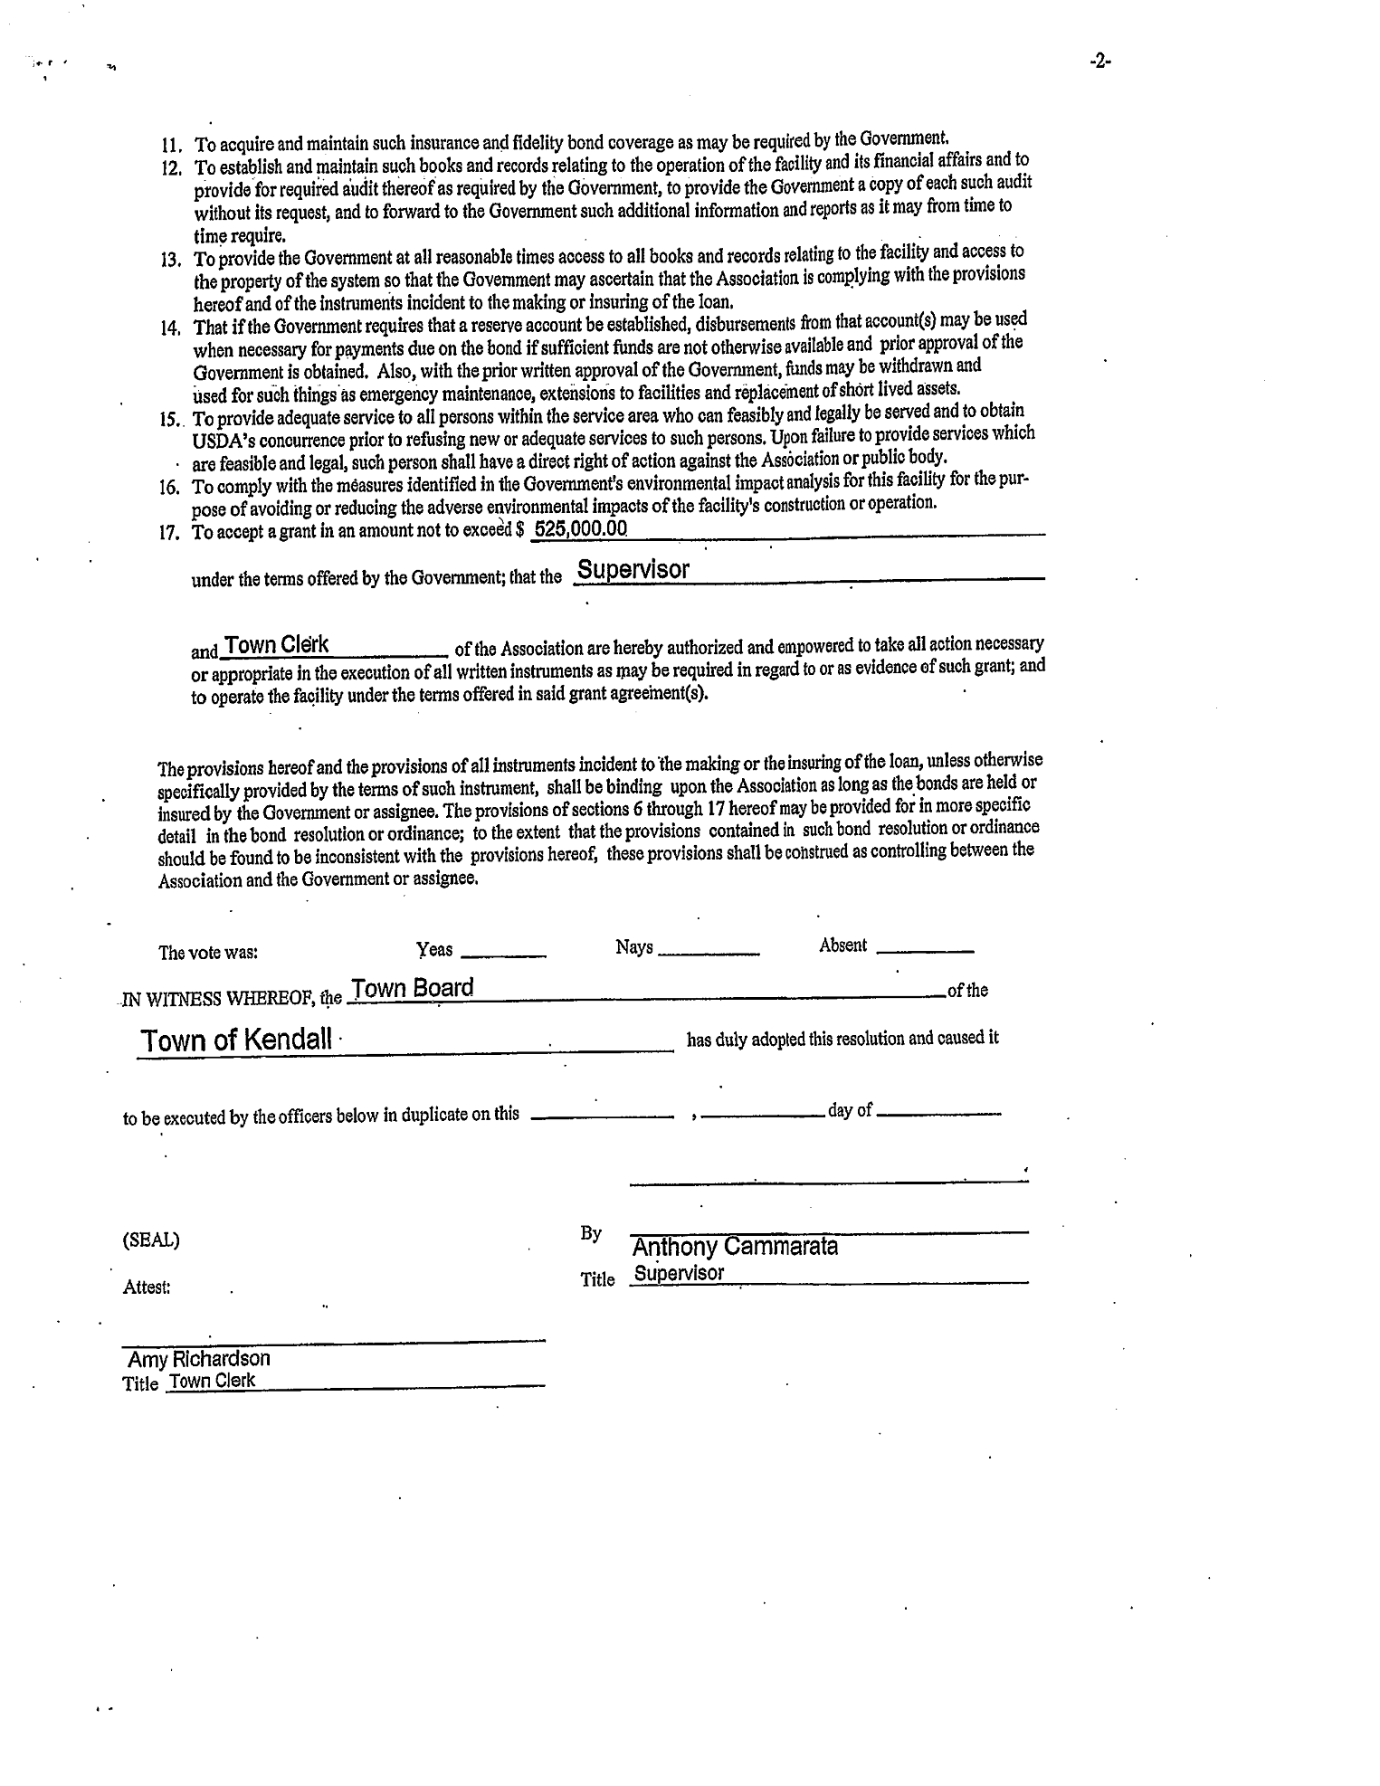

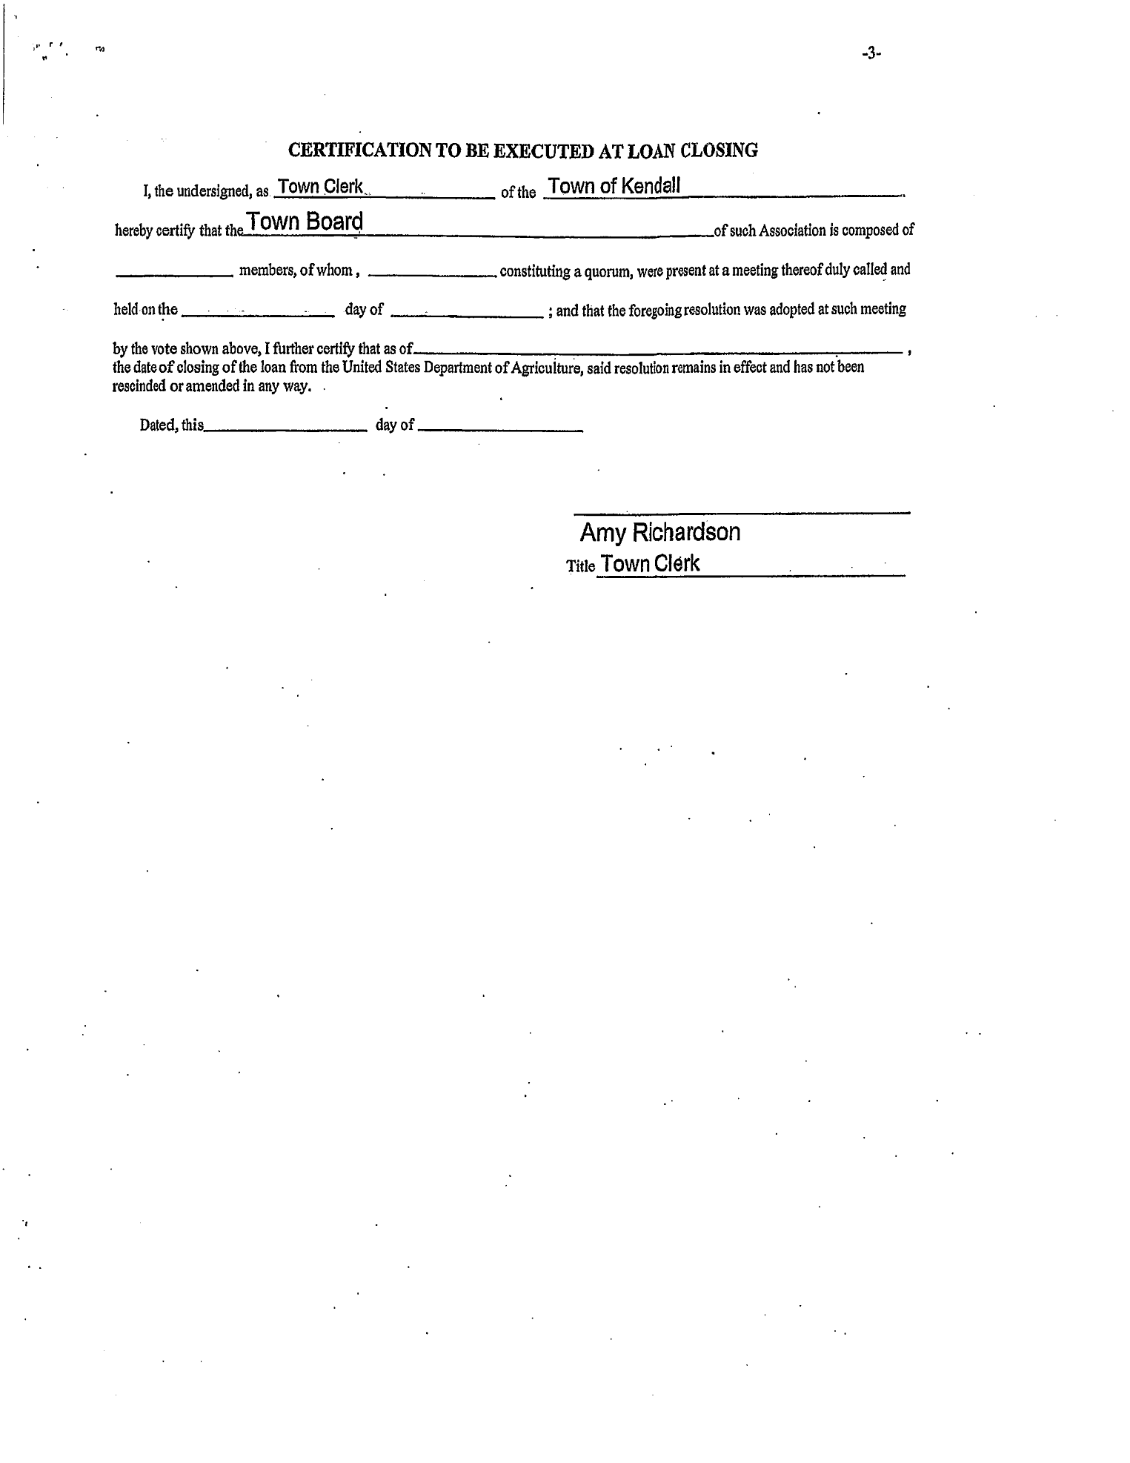
Supervisor Cammarata called for a vote, resulting in all ayes, and declared the motion carried.

Flow made the following motion, seconded by Szozda:

RESOLUTION 45-0117 AGREEMENT WITH LABELLA ASSOCIATES FOR PROFESSIONAL SERVICES RELATED TO POTENTIAL WATER DISTRICT NINE
Be it hereby resolved that the Kendall Town Board authorizes Supervisor Cammarata to enter into an agreement with La Bella Associates, P.C., for engineering services related to the water distribution improvements and extension to be constructed within potential Water District NINE. This is subject to review and approval by Attorney Meier as to form and content.
Supervisor Cammarata called for a vote, resulting in all ayes, and declared the motion carried.

This month, two Abstracts were created, in order to more easily determine those expenses to be paid from the 2016 Budget prior to close-out, and those which are 2017 expenses.

Szozda motioned to accept the claims as presented, seconded by Flow; all ayes:

PAYMENT OF CLAIMS 2016

General Fund Abstract 14 $ 2,074.67 Vouchers 950-958,960
Highway Fund Abstract 14 $ 189.00 Voucher 950
Light District One Abstract 14 $ 542.38 Voucher 955
Light District Two Abstract 14 $ 317.98 Voucher 955
Light District Three Abstract 14 $ 186.29 Voucher 955
Water District Six Abstract 14 $ 1,410.79 Vouchers 956,959,960
$ 4,721.11

Flow motioned to accept the claims as presented, seconded by Szozda; all ayes:

PAYMENT OF CLAIMS 2017

General Fund Abstract 1 $ 29,488.05 Vouchers 1-5, 7-17, 32
Highway Fund Abstract 1 $ 20,869.75 Vouchers 2, 11, 18-31
Water District Two Abstract 1 $ 2,260.00 Voucher 6
Water District Three Abstract 1 $ 4,555.63 Voucher 6
Water District Four Abstract 1 $ 17,508.13 Voucher 6
Water District Five Abstract 1 $ 6,479.38 Voucher 6
Fire District Abstract 1 $ 33,481.00 Voucher 11
$114,641.94

OLD BUSINESS

Defibrillators – availability and training
$1,199 will be provided toward this from the Justice grant. Bids will be sought.
Kendall’s Finest
No update
Solar Moratorium
May need to be extended, as solar code will likely not be in place before the moratorium expires.
Water District 9
Meeting scheduled with LaBella. WD 9 will connect the potential Water Districts 7 and 8 to each other.
Marina – nothing new
Voting machines – Town may dispose of as it desires. They can be declared surplus and sold for scrap.

NEW BUSINESS

Surveillance cameras will be placed around and in the Town Hall, including in the meeting room. The justification is that it may deter criminal activity or help to prosecute the perpetrators if any does occur. Funds for these cameras will be provided by the Justice grant.

Attorney Meier asked the Board to call an executive session to discuss pending litigation.
Councilwoman Flow made a motion to go into executive session to discuss pending litigation, seconded by Councilwoman Szozda; all ayes. Executive session called at 7:42 p.m. Open meeting was returned to at 7:58 p.m.

If decisions are derived during an executive session, rather than simply discussion, those decisions must be recorded in official minutes. During this executive session, a decision was made to have Attorney Meier draft a Notice of Appearance on behalf of the Town Board to be filed with the Orleans County Court regarding litigation over a drainage issue.

Cammarata asked for a motion to recess rather than adjourn this meeting, so resolutions pertaining to Water District Seven can be addressed before the regularly scheduled February meeting. Flow called for recess until February 7th at 7:00 p.m., seconded by Szozda; all ayes. Meeting recessed at 8:00 p.m.

Respectfully Submitted,

Amy K. Richardson,
Kendall Town Clerk

